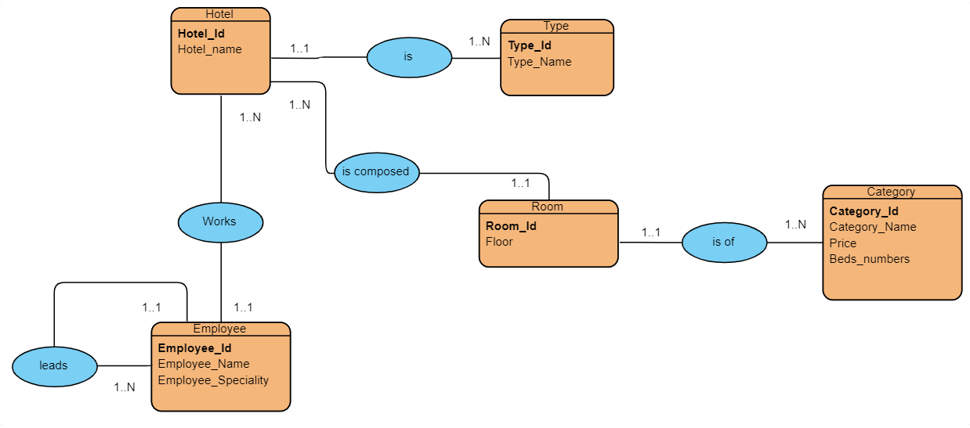

-Hotel (Hotel_Id, Hotel_name, #Room_Id, #Employee_Id)
-Type (Type_Id, Type_Name, #Hotel_Id)
-Room (Room_Id, Floor, #Catgory_Id)
-Category (Category_Id, Category_Name, Price, Beds_numbers)
-Employee (Employee_Id, Employee_Name, Employee_Speciality)

